MATING CALL

PROJECT PROPOSAL

A Report

Presented to

Faculty of Fine Arts

Concordia University

In Fulfillment

of the Requirements

of CART 398

By

George Kerasias

ID: 40283826

Philippe Beauchemin
ID : 40337391

Concordia University
Tables of Contents

1. Project Description 3
2. Objectives 4
3. Timeline 5
4.Software 5
5. Hardware 6
6. IML Components 6
7. Similar Projects 7
9. Literature Review 8

1. Project Description
MATING CALL is an interactive installation and conceptual app that reimagines online dating through the lens of biological signaling and explicit, embodied performance. Based on animal behavior, it critiques the way dating apps promise connection through optimization while often producing learned, machine-legible behaviors instead of intimate, human behaviors.
Participants create and perform custom “mating dances” along custom “mating calls” determined through a two-step ML pipeline (personalization → performance). The experience runs inside a single-screen app interface where swipes and chats are replaced by gestures and calls.
Here is the participant walkthrough:
1) Onboarding: The participant sees a full-screen prompt: “Generate your Mating Signature.” They complete a 10-question satirical questionnaire (environment, circadian rhythm, territoriality, display preference, etc.).
2) Signature generation: The participant’s answers map to a custom mating call, algorithmically generated in Max/MSP. The mating call’s sound information is then mapped onto a sequence of poses, a “mating dance” generated in TouchDesigner for the user to perform.
3) Courtship: Browsing other profiles reveals their archetype + call preview. To “message,” the participant must match the other person’s mating dance within a threshold; a successful courtship reveals the full profile.

2. Objectives
There are three main objectives in designing MATING CALL:
- To develop a layered, interactive environment that connects self-identification, bodily expression, and social performance. Through these three dimensions, the work aims to foster embodied connection between participants. The artistic intent is to create an experience where the technological system abstracts itself, allowing the user to be fully immersed in the performative act.
- To integrate human lyrical motion into a performative dating app interface as a form of satirical commentary on online dating. By translating digital rituals associated to online matchmaking – such as profiles, swipes, chats – into physical gestures, the project critiques the ways in which connection has become mechanized.
- To explore parody as a method of critique for algorithmic matchmaking and behavioral quantification. The work uses humor and exaggeration to reveal how systems that claim to understand human compatibility often reduce intimacy to data-driven outputs.
Beyond these primary goals, MATING CALL also contains several sub-goals that support the technical and experiential design of the piece:
- User Profiling: A short questionnaire gathers personal traits that are mapped to “call-dance” archetypes, forming the basis of each participant’s unique mating signature.
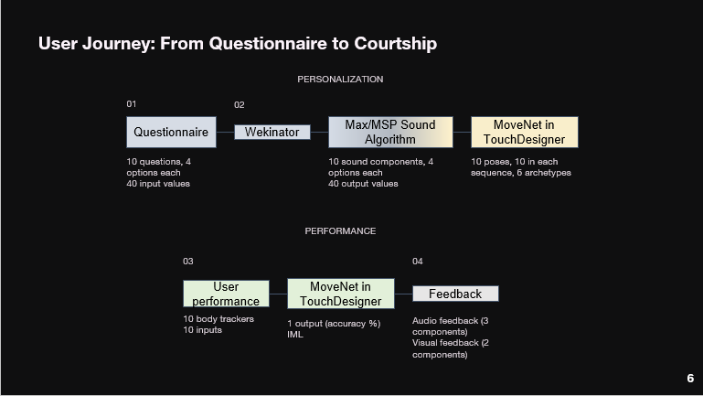
- Machine Learning Models: Two ML models drive the installation in three stages. (1) a personalization step built with Wekinator inside Max/MSP uses questionnaire data to train and generate the participant’s mating call, essentially mapping the user’s answers to algorithmic variations of the sound components; (2) a generation step, an IML model designed with MoveNet inside TouchDesigner, trained on movement archetypes to construct the embodied performance system, it maps the sounds to poses for “mating call” generation; (3) an evaluation step, during the performance MoveNet tracks the user’s body and evaluates the user’s accuracy in real-time; (4) this information is used to create feedback on the playback of the mating call performed, affecting the pitch and distortion of the track (see Figure 1).
Figure 1. Two ML models, 4 steps
- Media and Interface Design: Visual design, sound propagation, and interface aesthetics aim to heighten immersion and evoke the feeling of a “living” dating app environment.
- Evaluation: The evaluation of performances is structured as a regression process, assessing compatibility and courtship “success” during the performance based on body tracking to determine the accuracy of the participant’s motions. On screen, “success” will be visible to the participant through visual feedback; the profile for the archetype being performed will display a heart.

3. Timeline
Week | Task | Outcome
Oct 23 | Submit proposal | Pipeline sketch ideation
Oct 30 | Oral presentation | Feedback integrated  Demo: pipeline sketch + working on MoveNet capture + Max sound algorithm patch
Nov 5–10 | Data collection & labeling | 30–50 takes per archetype (pose+audio)
Nov 11–20 | TD ↔ Wekinator via OSC; feature engineering | Classifier v1; similarity meter
Nov 21–30 | Presentation
Dec 11 | Final report | Documentation complete

4.Software
- Max/MSP – Assigns variable inputs to sound components and outputs a “mating call”.
- Wekinator – Maps questionnaire inputs to sound components in Max/MSP and archetype in TouchDesigner.
- TouchDesigner – Provides the visual interface, including the dating app skin and real-time animated feedback.
- Python (OSC Communication) – Manages real-time data exchange between Wekinator and TouchDesigner.
- MoveNet – Handles pose detection and extraction of movement features.

5. Hardware
- Laptop with camera and microphone.
- Optional Kinect or USB Webcam for full-body movement capture.
- Projector for displaying visuals in the installation context.

6. IML Components
Stage | Model Type | Input | Output | Purpose
1.Personalization (call + archetype) | Regression | Questionnaire data → categorical traits (designed relationship between user’s answers and specific animal features) | “Mating call” (sound) + visual archetype (e.g. “Bird of Paradise”, “Wolf Howl”) | Assigns each user a mating identity
2. Personalization (dance) | Regression | Call sound information (volume information, variation over time) | Sequence of poses (“mating dance”) | Generates a dance for the user to perform
2. Performance | Regression | Pose detection (joint angles, amplitude of motion) | Match accuracy score | Evaluates how closely the user performs their archetype
3. Matchmaking | Rule-based logic + probability | Two performance scores | “Successful courtship” outcome | Determines if users are compatible

Training data will include multiple takes per call-dance type (approx. 30–50 samples). Users’ new performances will feed into the system iteratively, allowing real-time retraining and adjustment, emphasizing the interactive nature of learning.

7. Similar Projects
- Caramiaux, Baptiste, and Marco Donnarumma. 2020. “Artificial Intelligence in Music and Performance: A Subjective Art-Research Inquiry.” arXiv Preprint. https://doi.org/10.48550/arXiv.2007.15843. https://www.researchgate.net/publication/343390052_Artificial_Intelligence_in_Music_and_Performance_A_Subjective_Art-Research_Inquiry
  - This work describes a five-year collaboration between art practice and HCI research, combining machine learning with interactive music performance and choreography.
  - Key takeaway: how ML frameworks become part of the artistic workflow rather than just a backend.
- Plant, Nic, et al. 2020. “Interactive Machine Learning for Embodied Interaction Design.” In Programming for Moving Bodies, edited by … [publisher info], [pages]. https://ualresearchonline.arts.ac.uk/id/eprint/16500/1/Plant_et_al_ProgrammingForMovingBodies2020.pdf
  - This project introduces tools and methods for designing movement-based interactive systems using IML.
  - Key takeaway: using IML as a rapid prototyping method for embodied interfaces.
- Scurto, H., et al. 2017. “Shaping and Exploring Interactive Motion-Sound Mappings for Music.” In NIME 2017 Proceedings, paper 0077. https://www.nime.org/proceedings/2017/nime2017_paper0077.pdf

  - This work describes mapping human motion to sound in an interactive system, with ML/online learning components.
  - Key takeaway: how multimodal inputs (motion + sound) can be mapped with ML to generate interactive audio feedback.

9. Literature Review
- Visi, Federico Ghelli, and Atau Tanaka. 2020. “Interactive Machine Learning of Musical Gesture.” arXiv Preprint (Nov). https://doi.org/10.48550/arXiv.2011.13487. https://www.researchgate.net/publication/346475742_Interactive_Machine_Learning_of_Musical_Gesture
  - This chapter gives an overview of IML techniques applied to musical gestures, emphasizing the challenges of tracking and feature extraction for embodied interaction. Good theoretical foundation for your gesture + sound ML pipeline.
- Jourdan, Théo, and Baptiste Caramiaux. 2024. “Qualitative Inquiry on Machine Learning in Musical Performance.” [Journal] (May). https://arcol.isir.upmc.fr/wp-content/uploads/sites/3/2024/05/paper.pdf
  - This paper analyses how ML is used in musical performance contexts, drawing on qualitative methods. It adds depth to the discussion of performative, interactive ML systems.
- Chen, X., et al. 2023. “A Comprehensive Study of Emotional Responses in AI Installation Art.” Sustainability 15(22): 15830. https://doi.org/10.3390/su152215830. https://www.mdpi.com/2071-1050/15/22/15830
  - This research investigates emotion recognition ML in installation art, which gives insight into how user performance can be evaluated/ classified and how interactive installations create emotional feedback loops.

